Loved Ones,

We’re so excited that you will be joining us in New York for our wedding! Many of you are traveling from far away to attend, and many of you will be coming to New York for the first time. We’ve put together some notes and maps to help you navigate both the wedding and the city.

For ongoing updates on wedding news or other info, please visit our website: www.accone.com/wedding, or contact us directly: Tanya, (646) 229-2572, tanya_accone@yahoo.uk.co; Jay (917) 930-7303, jay.p.huber@gmail.com

To the right is a map of lower Manhattan, which will help you orient yourself to the more detailed maps that follow. This map also contains some points of interest – World Trade Center site, Empire State Building, etc. – that you might want to visit during your time here. As a quick reference, Tanya and Jay’s apartment is just to the left of the Times Square marker, just above 42d Street. The wedding will be in Central Park, at the Conservatory Gardens, which are located on the right edge of Central Park, almost all the way up at the northern edge. The reception will be at Tavern on the Green, which is along the west edge of Central Park, just below the Museum of Natural History marker.

There are many great resources on the web for tourist activities, and we’ll be updating the site to include some of those.
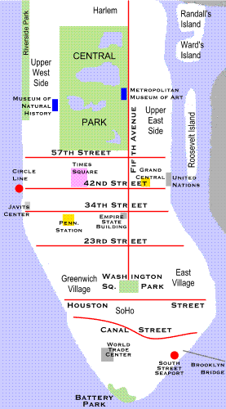

Hotels

We’ve reserved a block of 15 rooms at the Hilton Garden Inn, 790 8th Avenue at 48th Street, New York, NY 10019, (212) 581-7000. This is only a few blocks from our apartment.

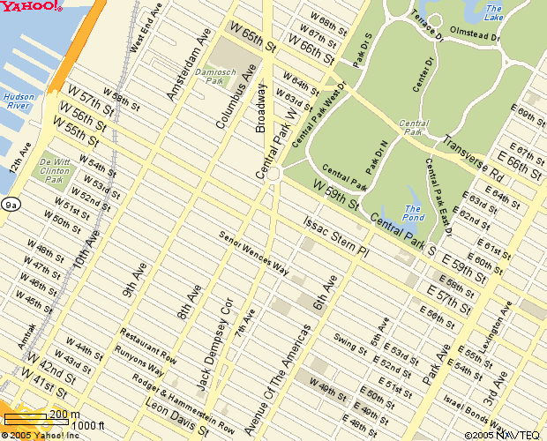
Tanya and Jay’s apartment 360 W. 43d St., b/w 8th and 9th Avenues

Hilton Garden Inn
790 8th Avenue @ 48th Street
(212) 581-7000
New York, NY 10019

Tavern on the Green
Central Park @ W. 67th Street
New York, NY 10019

The rooms are $199 for a king-size bed, or $219 for 2 queen beds (these are actually decent prices for a New York City hotel room). You should call the hotel directly and ask for one of the rooms blocked for the Accone/Huber wedding. These rooms will be held at this rate until one month before the wedding (until April 25th), after which this rate can’t be guaranteed, so please try to book before then. If they have run out of rooms please give us a call and we will try to add more.
Tavern on the Green
Central Park at West 67th Street

You may wish to try other hotel options to try and find a better rate, or if you would like to stay in another part of the city. Via the websites Hotels.com (www.hotels.com); Orbitz (www.orbitz.com); and Expedia (www.expedia.com) you may be able to find a better deal. If you go this route, we would encourage you to check out the reviews of the hotel on Trip Advisor (www.tripadvisor.com), where you will find user reviews of almost every New York City hotel.

Another possibility might be to rent a private apartment via Craig’s List vacation rentals (http://newyork.craigslist.org/vac/). With this method, you would rent someone’s apartment while they’re out of town, common for New Yorkers on Memorial Day weekend. If you go this route, Tanya and Jay will be happy to scope out the apartment ahead of time to ensure you’re getting what’s advertised.

Wedding Ceremony

The Wedding Ceremony will take place at the Conservatory Garden in Central Park, entrance located at 105 St. and Fifth Avenue, in the southern, or “secret”, garden (http://www.centralparknyc.org/virtualpark/northend/conservatorygarden). The ceremony will begin promptly at 5pm. Limited seating will be available, with priority given to seniors (in the event of inclement weather, which at a minimum must include thunder, lightning and serious rain, the ceremony will be held at 6:30 at Tavern on the Green). Other guests will be asked to stand for the duration of the short ceremony. Upon the conclusion of the ceremony there will be a short interlude for photographs, following which a bus will transfer the wedding party and all guests to Tavern on the Green.

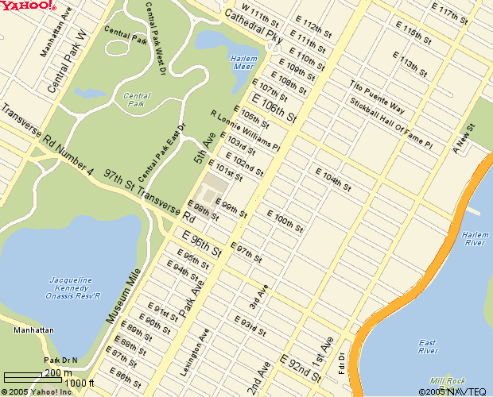
Conservatory Garden
105th St. @ Fifth Avenue
New York, NY 10019

Getting To and From Manhattan

If you are flying in, you will be arriving at one of 3 airports in the New York metro area: 1) LaGuardia (“LGA”); 2) Kennedy International (“JFK”); 3) Newark Liberty International (“EWR”). Getting from the airport to the city may seem intimidating, but there are several reasonable options no matter where you land that make it easy.

LaGuardia

http://www.panynj.gov/aviation/lgtsmain.HTM

Options include taxis, private buses, and the city transportation network. If you are more than one person, we recommend simply taking a taxi, which can be procured at a taxi stand right outside the baggage claim (you may have to wait a few minutes in queue). Cost will be approximately $30-40, which includes fare, tolls ($4.50 for the Queens-Midtown tunnel into Manhattan, for example) and tip. A taxi will drop you off right at the door of your destination. Please give the cab driver your address as well as the cross streets (e.g., 360 West 43d Street, between 8th and 9th Avenues). As a general rule tips are 15% of the fare.

Another option is to take a private bus service, such as Super Shuttle or the New York Airport Service Express Bus. These run $12-15 per person. With Super Shuttle, you may have to ride around for a bit as the service drops off other passengers before you, but it will eventually drop you off at your door. The Airport Service Express Bus serves three locations: Grand Central Terminal (East 42d Street @ Park Avenue); New York Penn Station (West 32d Street b/w 7th and 8th Avenues); and Port Authority Bus Terminal (8th Avenue b/w 40th and 42d Streets). From there you can take a taxi or public transportation to your lodging. If you are staying the Hilton Garden Inn and wish to take the New York Airport Service Express Bus, you should take it to Port Authority.

JFK

http://www.panynj.gov/aviation/jgtsfram.htm

Again, a taxi is the most convenient option. Taxis from JFK are $45 flat-rate to all points in Manhattan, not including toll and tip. As with LaGuardia above, you procure a cab from a cab stand immediately outside the baggage terminal. Look for the booth with a uniformed attendant. It is more common at JFK to be accosted by “gypsy” livery drivers offering you a ride to Manhattan. Do not accept these offers, as the will try to rip you off and you will have no recourse.

Other options include Super Shuttle ($17-19 per person door to door), as well as New York Airport Service Express Bus ($15 per person) to one of three destinations: Grand Central Terminal (East 42d Street @ Park Avenue); New York Penn Station (West 32d Street b/w 7th and 8th Avenues); and Port Authority Bus Terminal (8th Avenue b/w 40th and 42d Streets). From there you can take a taxi or public transportation to your final destination. If you are staying the Hilton Garden Inn and wish to take the New York Airport Service Express Bus, you should take it to Port Authority.

Newark

http://www.panynj.gov/aviation/egtsmain.HTM

Taxis are more expensive from Newark – upwards of $60. Newark Liberty Airport Express Bus ($13 per person) runs service to many destinations in Manhattan: Grand Central Station, Penn Station and Port Authority as listed above, as well lower Manhattan destinations, see the web site above for details. If you are staying the Hilton Garden Inn and wish to take the Newark Liberty Airport Express Buso, you should take it to Port Authority. Super Shuttle also runs door to door service from Newark ($15-19 per person).

The Airtrain rail link is another convenient option ($14 per person). A monorail will pick you up from any of the Newark terminals (look for signs directing you to the Airtrain), and deposit you at the New Jersey Transit rail station, which runs direct to New York’s Penn Station (West 32d Street b/w 7th and 8th Avenues), with intervening stops at Newark Penn Station and Secaucus Junction – that is not a typo, you must go through Newark Penn Station to get to New York Penn Station. New York Penn Station is the terminal destination of this train.

